**Empowering Students through Android Applications**

Authors: Melissa Serrano, Alain Edwards, Sifat Islam, Ravi Shankar, Iris Minor, Susanne Lapp

**Abstract**

During the fall 2014 semester at FAU a group of undergraduate students created an app to empower middle school students called Cityville, which had the highest ranking among judges at the end of the semester. The pilot version of the Cityville app allows users to add community events and report locations of concern in their community. I propose to enhance the pilot version of Cityville by allowing users to create a personal profile using the Processing programming language, integrate the app with their preferred social media account, and implement web crawling and social media mining techniques to lay the groundwork for some events and reports in the database. I have included mockups of my proposed changes. I feel that the enhancements I have proposed are extremely important to obtain the amount of usage we are wanting out of the students with the app. Without a significant amount of usage it would make Sifat’s research data very sparse and likely inaccurate. Upon implementation of my proposed enhancements we will have achieved an Android app which will empower middle school students as well as provide Sifat with useful data which he can use in his analysis.

**Background**

The expansion of internet use on mobile devices and the vast accessibility to technology since the turn of the millennium has greatly empowered our society. Twenty years ago a child might have asked his dad how to fix the chain on his bicycle when it fell off, now that same child won’t wait for dad to get home from work– he’ll look it up on YouTube! Having an endless sea of knowledge at our fingertips is a great empowerment tool. But does everyone realize how empowering the internet and technology is?

Bill Gates once stated, “As we look ahead into the next century, leaders will be those who empower others.” During the fall 2014 semester at FAU, Professor Shankar’s undergraduate Android Application Development class showed that all of us are leaders, because every one of us has the ability to empower others in some way. With suggested topics from community youth counselor Iris Minor, the students developed many Android applications designed to empower students. <https://github.com/RShankar/Empower-App-Cityville-Fall-2014> Among the apps created the Cityville App was ranked the highest by a group of academic, high tech, and movie industry professionals at FAU, and therefore chosen to be used in a study to analyze STEM interest amongst middle school students. With my contributions, the Cityville App will empower middle school students by allowing them to add community events or safety reports to Cityville that were not already collected, learn basic programming skills while creating and sharing their profile, and integrate Cityville with their preferred social media app. The usage of Cityville by the middle schoolers will then be analyzed by PhD candidate Sifat Islam to study the students’ usage as it pertains to STEM interest and activities.

**Pilot method**

Among the Android apps developed by Professor Shankar’s undergraduate class was ‘Cityville’ created by Alain Edwards, Adam Moulton, and Lance Williams. Cityville’s pilot method features a dynamically loading grid view, interactive Google Maps view, reporting of neighborhood safety information, a form to allow users to post a city event, and a form that allows users to report safety advisories. The Java programming language was used to develop the core functionality of the Android application and it is extended by the use of the Parse.com and Google Play Services plugins. Two Google Play Services APIs were used: Google Maps API and Google Analytics API. Google Maps API is used to allow for an interactive map view. The interactive map view allows users to see locations of events and safety alerts such as locations of police, fires, and traffic posted within the Cityville app. Google Analytics API is used for reporting and tracking the usage of the Cityville app. Some of the data the pilot version of the app currently tracks are the number of times a particular view is loaded, the number of events posted within a specified time period, number of safety reports posted within a specified time period, what type of devices are being used to access the application, among other metrics. The Parse.com plugin is used so that all the event and safety advisory data can be stored in the Parse database.

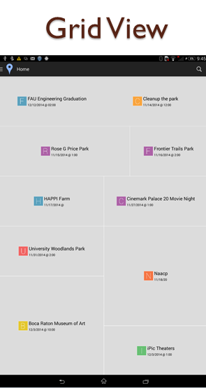 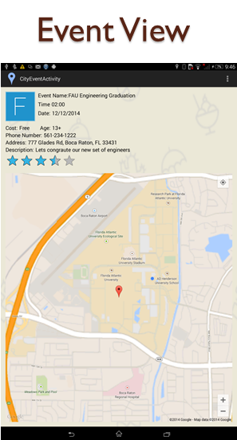 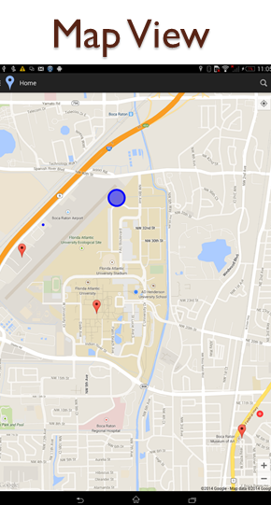

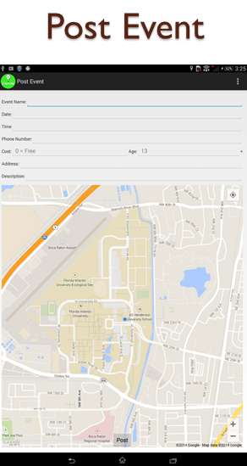 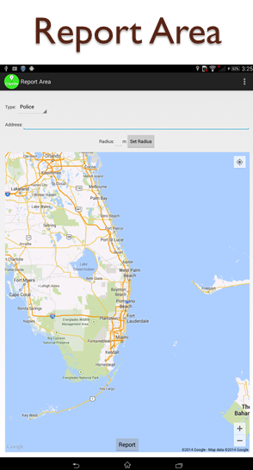

**Proposed Enhancements**

To enhance the pilot version of Cityville developed by the undergraduate students I propose to allow users to learn basic programming skills while creating and sharing their profile, integrate the app with their preferred social media account, and implement social media mining techniques to lay the groundwork for some events and reports in the database.

The app will allow the user to create a personal profile using Processing programming language. For the middle school students we will have the Andriod Processing App installed on the Nexus 7 tablets. I will provide a tutorial for them with a skeleton code showing them the basics of programming in Processing. <https://drive.google.com/file/d/0BxbisLdZYFOLY2Q1MVc4Zncxcm8/view?usp=sharing> This will empower the students to learn how to program and write their own profile in code. I will also provide a tutorial for the students to upload their finished profile code. The tutorial series for creating the profile and submitting it is located on YouTube. <https://www.youtube.com/channel/UCx_MZ6IfjTZcyk50pa9snYA> Once all profiles have been uploaded to Github I will package them with the CityVille code in an updated APK file to provide to Iris, this way the students and see their profile integrated with the CItyVille app. We will store data in Parse.com such as how many lines of code the student programmed for their profile and which API functions did they use for it. Also any textual information they include in their profile as well as how many other profiles they view. Below I have included a visual mockup of the proposed profile feature.

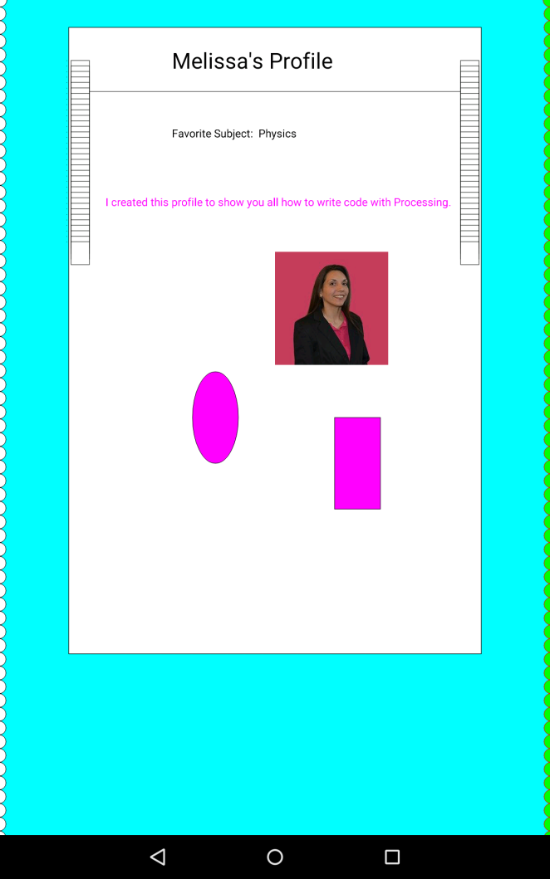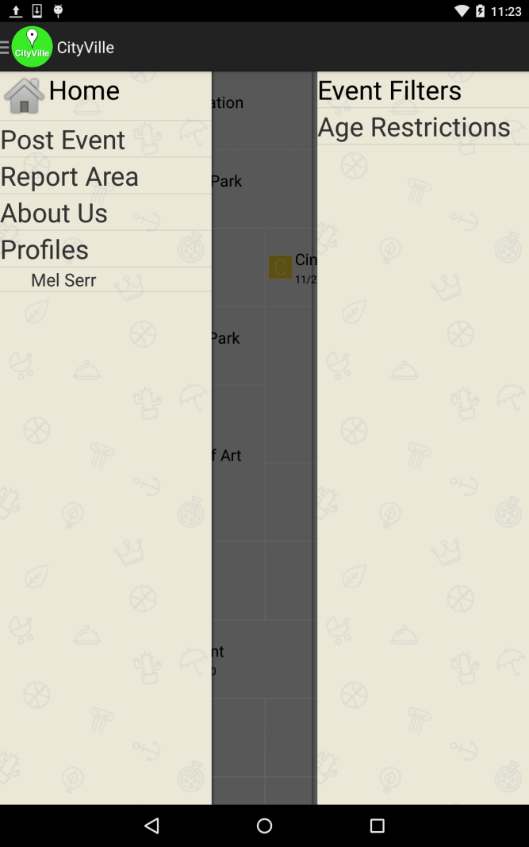

Most importantly, I will enhance the app to allow students to integrate the Cityville app with their preferred social media account. By doing this the students will continue using the social apps they always use and more readily upload events they are chatting about in their social networks to Cityville. With this feature I will provide Sifat with the means to analyze users’ connections in their social networks and relevant conversations they are having by recording the event that the student accessed this social network and allowing access to it. The graph below illustrates the results of a survey given to Iris’s group of 34 middle school students. Each student indicated that they have an account for each applicable social networks.

The results of the survey show that there was a tie for the majority of students using Instagram and KIK. Since Sifat needs to collect textual data to analyze students interest in STEM, we decided that Instagram would provide a limited amount of data for analysis. Based on these results we decided to integrate CityVille with KIK. The goal is to enable the student to share and add a comment related to the profile page they created with the Processing programming language, as well as other communications which can be used to analyze STEM interest. This way each of the shares and text can be stored in the Parse.com database so that Sifat can later analyze it. To measure how empowered the kids are we will track connections made within their integrated social media account, events and reports uploaded, as well as the extent of their programming in the profile they create.

TODO: KIK integration mock-ups

In addition to allowing users to post events and safety advisories, I propose to use social media mining to collect information for events and reports. Since many organizations post their upcoming community events on their FaceBook pages I will use the FaceBook API to collect the event information so it can then be stored in the Parse.com database. Since we know that for our purposes this app will be used by students in Broward County, Florida we can keep the events and reports obtained from the web mining limited to activities within Central and South Florida. However for the app to later become more widely used, time permitting I will develop an algorithm to retrieve and store events and advisories related to the users location and clear unrelated activities out of the database in order avoid bloating the database with unnecessary data.

<https://github.com/EmpowerMe/Melissa-Serrano>

**Results**

/*Comment about the end result of completed development***IMPLEMENTATION DETAILS*/

Write Code to Create a Profile

TODO: IMPLEMENTATION DETAILS of how well the process worked for the students to follow my tutorials and create their own profiles.

TODO: Summarize the quantity and quality of data collected from student profile creation

Social Media Integration

TODO: Implementation details of KIK API use

TODO: Summarize the quantity and quality of data collected from KIK integration

Social Web Mining to Add Events

TODO: Flowchart

**Discussion**

In order to give the app more “value” I feel it is important not to rely solely on user input of events and safety advisories, doing this may result in the app having a sparse amount of data. With my proposed enhancement of mining the web and social media for relevant events and reports it will give the students incentive to use the app, even initially. To give the app a more personalization and allow the students to learn basic programming I will introduce them to the Processing programming language. I am adding this aspect because it will allow the students to show empowerment and individuality by self-expression, while providing another metric to measure student empowerment. In order to increase usage of the app I think that it is extremely important to allow students to integrate the Cityville app with their preferred social media account. If this app is just another app they download they’ll probably take a look at it a few times and go back to their usual social apps whether it’s Facebook, Instagram, Snapchat, Tumblr, KIK, or any others. By giving the students this option, the app will work more closely with what they are already doing. This also allows for us to collect more data connected to each student for Sifat to analyze.

**Conclusion**

Upon implementation of my proposed enhancements we will have achieved an Android app which will empower middle school students as well as provide Sifat with useful data which he can use in his analysis by making the app easy to integrate with what the students are already doing and giving it the personalized feel they are accustomed to with many other social games and apps.

**References**

<https://github.com/RShankar/Empower-App-Cityville-Fall-2014/wiki>

/*Once research on APIs going to use for social web mining include those links here*/